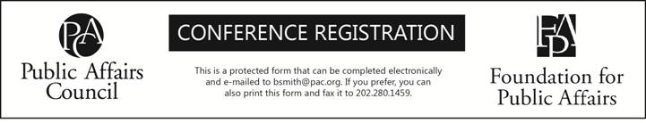
2013 Senior Executive Roundtable Series
CONTACT INFORMATION

Name |  | Nickname (for badge)
Title
Organization
Address
Address Two (Suite, Mail Stop, etc.)
City | State |  | Zip
Phone | Fax |  | E-mail
Do you need assistance to participate? | Vegetarian Lunch?

Please select the events in which you would like to participate. You must select a minimum of 2 events:
Strategic Planning for Public Affairs [Oct 29]
Shareholder Activism and Political Transparency [Nov 13]
Public Affairs as a Vehicle for Thought Leadership [Dec 5]

FEES
The cost to attend meetings in this series is $299 per event for both members and non-members. When registering for two or more meetings in this series, you will receive a 15% discount of your registration total.

- Two meetings in the series - $509
- Three meetings in the series - $763

PAYMENT
Payment must be received prior to the meeting. So that we may process your registration promptly, please fax your registration form now. Then send a copy of the form with your payment—which must reach us before the meeting date.

Check: made payable to the Public Affairs Council, 2121 K ST, NW #900, Washington DC 20037. Include a copy of this form.

Credit Card Payment: |  | Visa |  | AMEX |  | MasterCard
Card # |  |  | Expiration Date:
Signature

CANCELLATIONS. Cancellations received 21 days or more before the first day of the meeting will be fully refunded. For meetings where the registration fee is $275 or less, no refunds will be granted 20 days or fewer before the meeting. Otherwise, cancellations received between 20 and 10 days before the meeting will be charged a $200 administrative fee. Cancellations received between 9 and 5 days before the meeting will be charged a fee equal to half the registration fee (a minimum $200 administrative fee will apply for all events). No refunds or credits will be granted for cancellations received 4 days or fewer before a meeting or for no-shows. Cancellations must be submitted in writing via email or fax to 202-280-1459. You will receive confirmation of your cancellation via email. Substitute registrants from the same organization will be honored with prior notification to the Public Affairs Council. The Council reserves the right to cancel a seminar due to severe inclement weather or natural disaster. Registrants will receive a full refund of the seminar fee only. The Council will not be held responsible for any incidental charges incurred by the registrant due to seminar cancellations for the conditions listed above.

CONFIRMATION. Upon receiving your registration, we will send you a confirmation memo via e-mail. If it does not arrive within one week, please call 202.787.5950 to verify that you are registered. You will also receive a “Final Memo” approximately one week before the meeting. It will include important logistical information, a registrant list and the final agenda.

