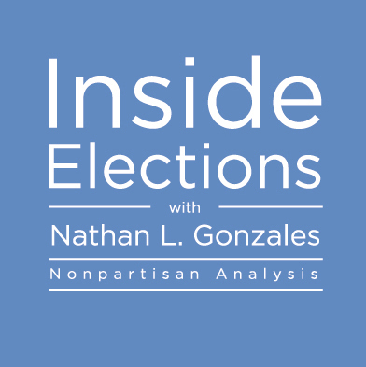

For more information, including sample issues and references, contact:

Nathan at (202) 210-3576 (cell)
Nathan@RothenbergGonzales.com
InsideElections.com/Subscribe

GOLD LICENSE - $5,000/year

- 24 issues of Inside Elections
- Co-branded PDF of every newsletter, with your logo, for direct, unlimited distribution
- One exclusive conference call
- Regular conference calls for all license subscribers
- Multiple, regular hard copies
- Online access for up to 100 people

SILVER LICENSE - $2,500/year

- 24 issues of Inside Elections
- Regular conference calls for all license subscribers
- Multiple, regular hard copies
- Online access for up to 25 people

INDIVIDUAL SUB - $249/year

- 24 issues of Inside Elections
- One regular hard copy
- Online access for one subscriber

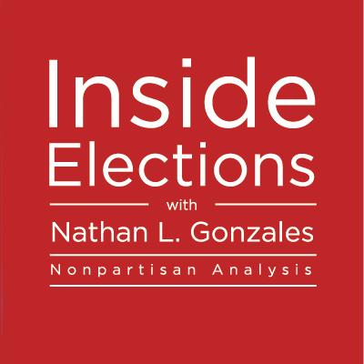

“Inside Elections is an important part of our effort to keep members informed about the national political landscape. It also provides us with another touch point to communicate to PAC members, which is vital to keeping them engaged and involved. The PAC branding is also a great way to promote the PAC within your organization.”
Zack Smith
Manager, Government Affairs, Experian
Gold License Subscriber

One Gold License subscriber solicited feedback from her folks. Here’s what she heard:

- Non-biased insider-type information
- Objectivity, empirical basis
- One of the few sources of information to be neutral and based on facts (not agenda)
- Unbiased
- A good breakdown of the issues and you can see the big picture and read into the details
- The report is clear and concise
- Fact based, non-partisan
- Very informative
- Extremely knowledgeable
- Political commentary is kept to a minimum
- Haven't read it yet
- Very detailed information at all election levels.

